*Notes of meetings*

*-UDIAC*

# Week 2

Meeting 06/09/2021

We talked about the brainstorming and went over the rules again.

We discussed the logo, because we didn’t like the font and the background needed to be transparent. We made some changes and decided to add “Creative Digital Agency” to the logo, because just “UDIAC” with the duck can be confusing, since no one has heard of our agency.

We decided that we should do three meetings during the week, on Monday, Wednesday and Friday.

Then, we looked for fonts the use with our logo. And thought about what we would create: a website, an app, a flyer, etc.

Meeting 08/09/2021

The meeting was online. Ali worked on the logo (changed the font, placement of text, etc.) and showed us some examples.

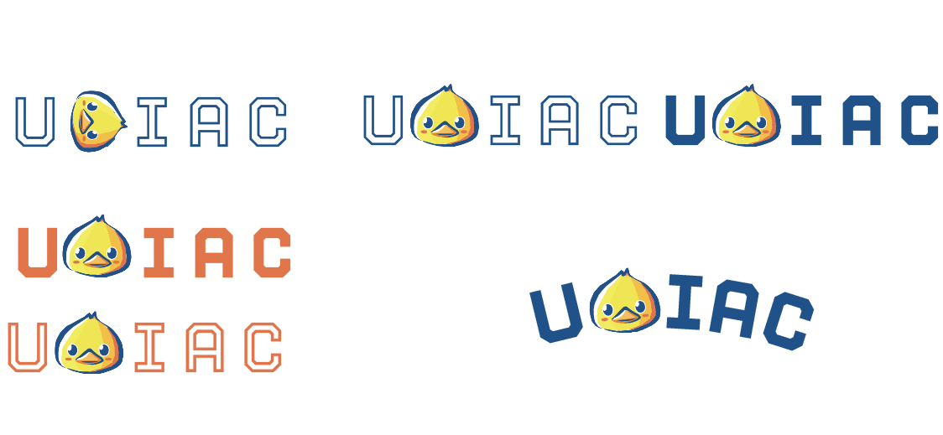

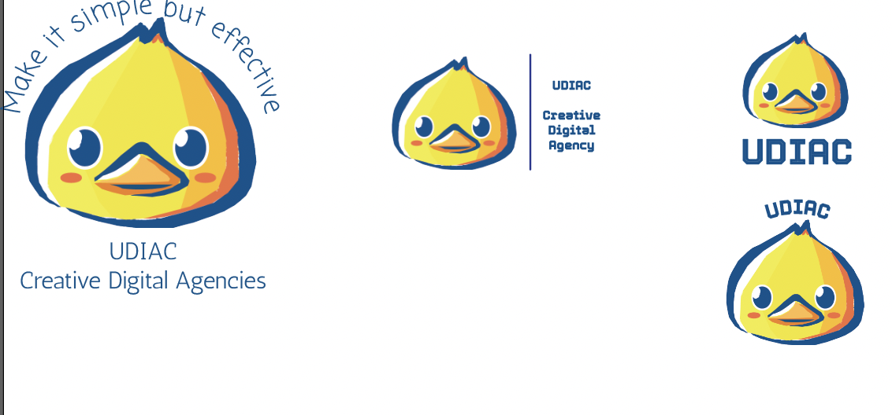

We all voted on one or two logos and all agreed on one.

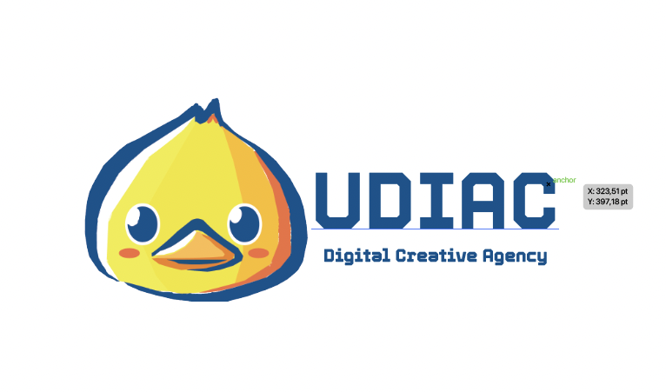

After we decided on the logo, we discussed the questions we could ask the client.

* What values and beliefs define Team Liquid?
* What makes them unique in the market? Strengths, weaknesses, opportunities, threats (SWOT).
* Who is your target audience? Do you have established buyer personas for each of your target customer groups?
* What are the top publications/blogs in your industry?
* What platform do your customers/fans prefer to communicate with you? Twitch
* What feature would you like to improve?

Umberto will work on the do’s and don’ts, and later he and Desislava worked on the presentation for the agency.

Meeting 09/09/2021

Today was the kick-off meeting with the client Marcel Schakenraad, he is the partnership manager for Team Liquid. He gave us information about Team Liquid in general.

Meeting 10/09/2021

Meeting at school.

Since Ali couldn’t attend the kick-off meeting, we started by explaining him what the assignment is about.

We created an account on Liquid+ to see what we should replicate for our project. Then we started brainstorming for companies. We came up with a lot of companies and created a mind map to visualize our ideas.

See below for the companies:

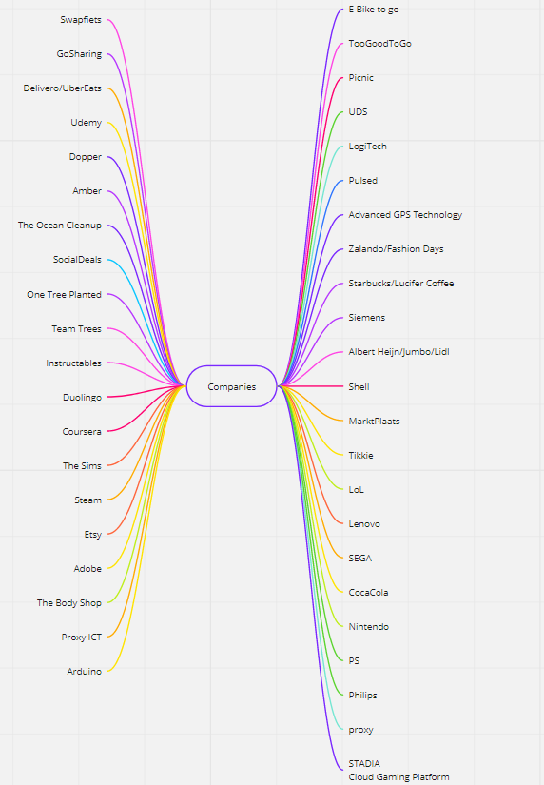

Then after coming up with these companies, we decided that each of us should pick one company and do research about them. Then, when we have finished the research we have to come up with ideas how we can help them with creating something as Liquid+. We will finish this on Monday and present it to each other after school.

# Week 4

Meeting 21/09/2021

The tasks were split between the team members. We decided to create a presentation and a report which includes our process/research. Everything needs to be ready by Wednesday. Umberto is going to present the pitch.

Meeting 22/09/2021

Everyone showed the tasks they have completed. We discussed the progress and gave feedback to each other.

# Week 5

Meeting 29/09/2021

We discussed what needs to be improved in our work flow .What are we going to do or what needs to change.Each team member gave their opinion.We chose our secretary (Catherine) by voting and a co-secretary(Umberto) that will help.

Meeting 30/09/2021

Everyone worked on the survey.We took a group photo. Ali is going to finish the brand guide.We discussed and come up with a plan for our next step.

# Week 6

Meeting 9/10/2021

Desislava splited some tasks with the team.We decided that everyone is going to do wireframes for Monday .Total of 3 pages. She showed us as well the notes she has made based on our data from the survey.For tomorrow everyone has to think of a name for our ‘points’ and to come up with some new challenges.

Meeting 10/10/2021

We choose Alis wireframe.Everyone has to do a mock-up which is going to be presented monday. We discussed Ali’s logo and gave some ideas on how to improve it.

# Week 7

# Week 8

Meeting 21/10/2021

Finished the logo for the loyalty program.Went through the design of the prototype and got feedback.Removed the search-bar and thought about the usability of the prototype.

Meeting 22/10/2021

We worked on the brand book together. Worked on the prototype and searched for real sponsors.

Meeting 23/10/2021

Catherine showed what she added in the prototype. Ali is going to go through the design and add final changes. Iris showed her progress in code and is going to separate the menu from the css of the other elements.

# Week 9

Meeting 04/11/2021

We asked for feedback and help for the database. We got a “mini tutorial” on databases,QR code and JSON. Iris and Catherine updated the prototype testing.We got feedback to update our second deliverable and we will be working on that as well.

Meeting 05/11/2021

We started building our project plan together.Ali got more information regarding the database. Iris and Catherine redid the personas and added the student interview.

# Week 10

Meeting 08/11/2021

Everyone was working together on the CMD methods and MOSCOW analysis .Ali created the design for each of them . Some posts were added as well to our blog.

Meeting 12/11/2021

Desislava interviewed Lucifer . Ali and Umberto continued to work on the database.

Meeting 14/11/2021

Did a quick recap. Penny posted new challenges which we plan to ask for more info.

# Week 11

Meeting 15/11/2021

Meeting 16/11/2021

Meeting 19/11/2021

Worked on the new challenges together . Created a new survey together and a document for persuasive design .Desislava created a survey for the founder of Lucifer .

# Week 12

Meeting 25/11/2021

Iris helped Umberto with the login page . Feedback from teachers on the logo to make the “of” more noticeable.

# Week 13

Meeting 30/11/2021

Everyone showed their progress in coding . Desi showed her design for the contact page and newsletter . Its needs to be updated to have the same look and feel as the other pages . Umberto showed his progress on the login page which still needs some work to be closer to the design in figma . Iris completed three pages - Home page, Reward page and Location page . By creating the mobile version for them and fixing the footer . Catherine showed the challenge page which still needs the pop-up and js for the game.

Meeting 03/12/2021

Everyone showed their progress so far . Desislava showed the finalyzed contact page design . Iris and Catherine have two different versions for the pop-up. Umberto showed the created responsiveness for the login page . We decided to focus on delivering the website first and then work on some challenges when we have time. Our deadline for coding is 15th of December.

# Week 14

# Week 15

Meeting 13/12/2021

Dessislava shared with the team her progress with the contact page .Ali was still working on the database.Catherine finished coding her pages. Iris is making small changes and helping Umberto.Umberto is still working on his pages.

Meeting 17/12/2021

Ali showed the progress with the database .Asked for someone to redesign the menu page .